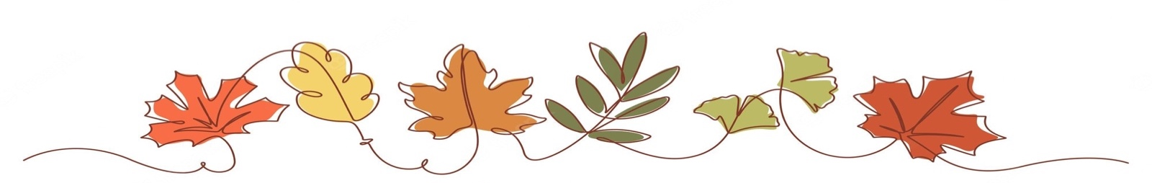
Rowan Autumn Newsletter

Welcome to Rowan! Welcome back to another year at St Edmund’s. Below is an overview of our class schedule, homework and what we are covering this term. If you have any questions, please do not hesitate to contact me via the office.
Best wishes,
Miss Edgar,
Weekly Schedule
PE | Wednesday and Thursday | We will be having our PE lessons every Wednesday and Thursday. Children can wear their PE kits on this day to school.
Book Day | Wednesday | Children will bring home a reading book and reading record as part of their homework. Please could they bring in both of these every Wednesday even if their book does not need changing.
Clarinet | Thursday | Children in Year 3 and 4 have clarinet lessons every Thursday.
Forest school | Year 4 – 20th November  Year 3 – 27th November | Children can come in their forest school clothes. Please ensure that they have a spare pair of footwear and spare clothes as they may get muddy! Also that they have coats and hats, gloves and scarves depending on the temperature.
Homework
Reading   | To make good progress it is important that children read regularly with an adult. Children will be assigned a book at their reading level which they can read more than once to help them read clearly and to add understanding of new vocabulary. Please make a note of any reading in their reading record. Reading other books of their choice as well is greatly encouraged.
Times tables   | Learning their times tables helps children with many areas of Mathematics. Therefore, we encourage Rowan to practise their times tables for 5-10 minutes as often as possible.  At the end of Year 4 children are required to take part in the National Times table check. This is taken on a computer and involves getting used to answering 25 questions quickly. Therefore, to get used to this each child will be practising their times tables every day.
What we are learning this term.
English | We will be doing a lot of reading this year and working on our reading skills this term. Our first book this year will be ‘The Miraculous Journey of Edward Tulane’, after this we will be reading ‘Into the Forest’ and then we will be reading an alternative version of a traditional tale called ‘Cinderella of the Nile’. We will be focusing on writing diary entries, a narrative from the boy’s point of view and their own version of the traditional tale. Handwriting will be a focus by ensuring that children are forming their letters correctly so that they are then able to join their handwriting.
Maths | In Mathematics, we will be making sure our knowledge of place value is secure before moving on to be able to add, subtract multiply and divide effectively. We will also be having weekly reasoning lessons to further develop children’s mathematical skills.
Science | This half term we will be learning about rocks. We will be learning how to classify rocks and how fossils are formed. We will also be investigating how soil is made of rocks and organic matter. During our science unit we will be learning the history of Mary Anning and her role as a palaeontologist.
Religious Education | This term we will be learning about the creation story from Genesis. We will be discussing what the story of creation tells us about God. As we investigate further we will be exploring how God created humans to be equal and how this links to the Catholic Social Teaching Value of human dignity.
PE | In PE this term we will be working on our personal development. We will also be focusing on developing our football and hockey skills.
History | We will be investigating what life was like in Roman Britain to discover why the Romans were so successful during their invasion of Britain.
Art | In art this term we will be developing our sketching and shading skills to create drawings which include a range of different mark making techniques. We will then move on to plan and create a final piece which incorporates a variety of line drawings and uses oil pastels.
Spelling | We will be continuing to practise spellings in school with investigations and short spelling games.
Clarinet lessons
In music we will be working on our performance skills. The children will be having clarinet lessons each week and will build their confidence in playing the instrument. Clarinets will come home after a few weeks for children to practice with and must be returned to school every Thursday.

