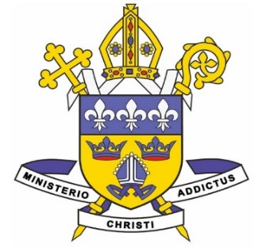
the DIOCESE of
EAST ANGLIA

St Edmund’s Catholic Primary School
Admission to Reception in September 2023
Supplementary Information Form

IMPORTANT: In accordance with the school’s published Admissions Policy (available on the school website), you are strongly recommended to complete and return this form.

Please return this completed form and any associated documentation by 10th February 2023
To St Edmund’s Catholic Primary School, St Mary’s Street, Bungay NR35 1AY.

If you wish to apply for a place for your child at St Edmund’s Catholic Primary School (for entry into Reception Year in September 2023) please provide the following information. This is necessary to allow each applicant to be placed in the correct category in accordance with our published admissions policy. Failure to provide complete information will make it impossible for us to recognise the correct category for your child and will lead to their being placed in a lower category. Please note that attendance at a nursery school does not guarantee a child a place at the same primary school.

It is essential that you also complete the Local Authority form and return it to the same Local Authority. Parents of children attending or due to attend State Schools should receive details of the Local Authority admissions process from their own Local Authority.

I have completed my own Local Authority’s school application form YES / NO

Name of Child . . . . . . . . . . . . . . . . . . . . . . . . . . . . . . . . . . . . . . . . . . . . . . . . . . . . . . . . . . .

Date of Birth . . . . . . . . . . . . . . . . . . . . . . . . . . . . . . . . . . . . . . . . . . . . . . . . . . . . . . . . . .

Name of Parent/Carer . . . . . . . . . . . . . . . . . . . . . . . . . . . . . . . . . . . . . . . . . . . . . . . . . . . . .

Home Address . . . . . . . . . . . . . . . . . . . . . . . . . . . . . . . . . . . . . . . . . . . . . . . . . . . . . . . . . . .

. . . . . . . . . . . . . . . . . . . . . . . . . . . . . . . . . . . . . . . . . . . . . . . . . . . . . . . . . . . . . . . . . . . . . . .

Telephone Number . . . . . . . . . . . . . . . . . . . . . . . . . . . . . . . . . . . . . . . . . . . . . . . . . . . . . . .

(Please turn over

- If Catholic, please state:

Date of Baptism . . . . . . . . . . . . . . . . . . . . . . . . . . . . . . . . . . . . . . . . . . . . . . . . . . . . . . . . . .

Place / Parish of Baptism . . . . . . . . . . . . . . . . . . . . . . . . . . . . . . . . . . . . . . . . . . . . . . . . . . .

Please enclose a copy of your child’s Catholic Baptismal Certificate. We cannot recognise children as being Catholic without this evidence.

- If your child is due to be baptised into the Catholic Church, is of another Christian denomination or is of another faith, please provide a copy of any Baptismal certificate or a letter of proof from a religious leader, as appropriate.

RETURNING THIS FORM

Please return this form and any associated documentation to St Edmund’s Catholic primary School, St Mary’s Street, Bungay, NR35 1AY by the 10th February 2023.

St Edmund’s Catholic primary School will send out an acknowledgement of receipt of this Supplementary Information Form to reassure parents their application has been received. Please allow two weeks for this acknowledgement to come through before contacting the School Office.

