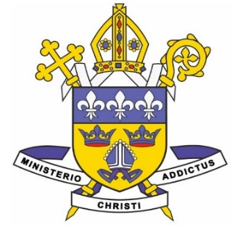
the DIOCESE of
EAST ANGLIA

St Edmund’s Catholic Primary School
In Year Admission 2021
Supplementary Information Form

Please return this completed form and any associated documentation to St Edmund’s Catholic primary School, St Marys Street, Bungay, NR35 1AY

If you wish to apply for a place for your child at St Edmund’s Catholic Primary School, please provide the following information.

Name of Child . . . . . . . . . . . . . . . . . . . . . . . . . . . . . . . . . . . . . . . . . . . . . . . . . . . . . .

Date of Birth . . . . . . . . . . . . . . . . . . . . . . . . . . . . . . . . . . . . . . . . . . . . . . . . . . . . . . . . .

Name of Parent/Carer . . . . . . . . . . . . . . . . . . . . . . . . . . . . . . . . . . . . . . . . . . . . . . . . . .

Home Address . . . . . . . . . . . . . . . . . . . . . . . . . . . . . . . . . . . . . . . . . . . . . . . . . . . . . . . .

. . . . . . . . . . . . . . . . . . . . . . . . . . . . . . . . . . . . . . . . . . . . . . . . . . . . . . . . . . . . . . . . . . . . . . .

Telephone Number . . . . . . . . . . . . . . . . . . . . . . . . . . . . . . . . . . . . . . . . . . . . . . . . . . . . . . .

- If Catholic please state:

Date of Baptism . . . . . . . . . . . . . . . . . . . . . . . . . . . . . . . . . . . . . . . . . . . . . . . . . . . . . . . . . .

Place / Parish of Baptism . . . . . . . . . . . . . . . . . . . . . . . . . . . . . . . . . . . . . . . . . . . . . . . . . . .

Please enclose a copy of your child’s Catholic Baptismal Certificate. We cannot recognise children as being Catholic without this evidence.

- If your child is due to be Baptised into the Catholic Church, is of another Christian denomination or is of another faith, please provide a copy of any Baptismal certificate, or a letter of proof from a religious leader, as appropriate.

